|  |
| --- |
| **DIGITAL SYSTEM DESIGN LABORATORY** |
| **LAB 3** |

**IMPLEMENTATION OF SEQUENTIAL LOGIC CIRCUIT USING VERILOG IN FPGA KIT**

### I. LAB OBJECTIVES

### This Lab experiments are intended to implement Basic Sequential Circuits in Verilog. Students are require to write test bench to simulate the given example code and Top level module to implement these codes in DE2-115 FPGA Kit.

### II. LAB EXPERIMENT EXERCISES

**AIM: WRITE VERILOG HDL CODES TO SIMULATE AND IMPLEMENT THE FOLLOWING DIGITAL SEQUENTIAL LOGIC CIRCUITS:**

1. DFF with Asynchronous Reset

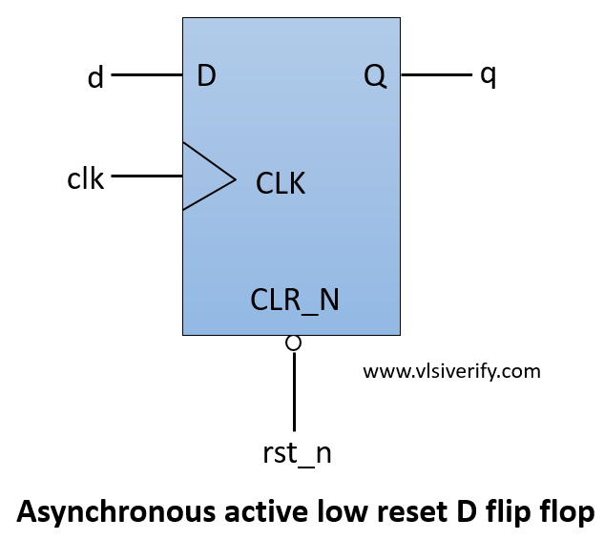

|  |  |  |  |
| --- | --- | --- | --- |
| Clk | Rst | D | Q |
| 0 | 0 | 1 | 0 |
| 1 | 0 | 1 | 1 |
| 0 | 1 | 1 | 0 |

|  |
| --- |
| **Top module** |
| module lab3_ex1(SW,LEDR,LEDG);  input [17:0] SW;  output [17:0] LEDR;  output [7:0] LEDG;    assign LEDR=SW;    D_flipflop_async(.d(SW[2]),.rst(SW[1]),.clk(SW[0]),.q(LEDG[7]));  endmodule |
| **Code** |
| module D_flipflop_async(  input clk, rst,  input d,  output reg q  );  always@(posedge clk or posedge rst)  begin  if(rst) q <= 0;  else q <= d;  end  endmodule |
| **Testbench** |
| module tb_D_flipflop_async;  reg clk;  reg rst;  reg d;  wire q;  D_flipflop_async uut (  .clk(clk),  .rst(rst),  .d(d),  .q(q)  );  initial begin  clk = 0;  forever #5 clk = ~clk;  end  initial begin  rst = 0;  d = 0;  #10 rst = 1;  #10 rst = 0;  #10 d = 1;  #10 d = 0;  #10 d = 1;  #10 d = 0;  #10 rst = 1;  #10 rst = 0;  #10 d = 1;  #20 $finish;  end  initial begin  $monitor("Time = %t | clk = %b | rst = %b | d = %b | q = %b", $time, clk, rst, d, q);  end  endmodule |
|  |
|  |

1. DFF with Synchronous Reset

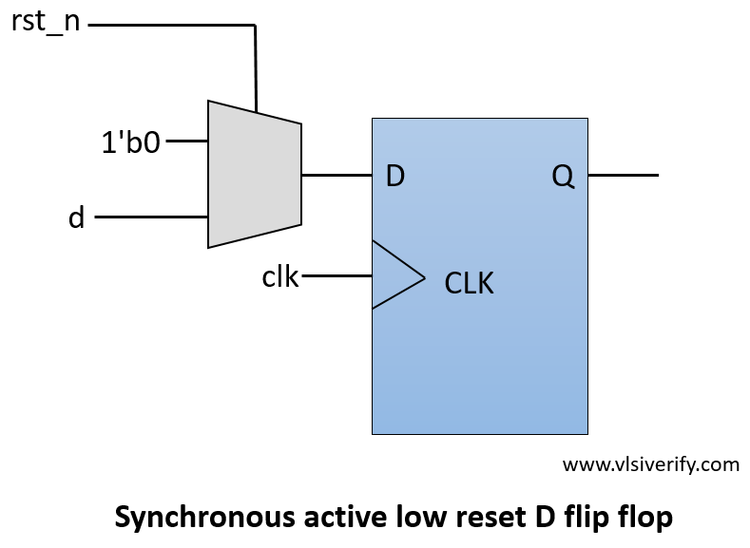

|  |  |  |  |
| --- | --- | --- | --- |
| Clk | Rst | D | Q |
| 0 | 0 | 1 | 0 |
| 1 | 1 | 1 | 0 |
| 0 | 0 | 1 | 0 |
| 1 | 0 | 1 | 1 |

|  |
| --- |
| **Top module** |
| module lab3_ex2(SW,LEDR,LEDG);  input [17:0] SW;  output [17:0] LEDR;  output [7:0] LEDG;    assign LEDR=SW;    D_flipflop_sync(.d(SW[2]),.rst(SW[1]),.clk(SW[0]),.q(LEDG[7]));  endmodule |
| **Code** |
| module D_flipflop_sync (  input clk, rst,  input d,  output reg q  );  always@(posedge clk)  begin  if(rst) q <= 0;  else q <= d;  end  endmodule |
| **Testbench** |
| module tb_D_flipflop_sync;  reg clk;  reg rst;  reg d;  wire q;  D_flipflop_sync uut (  .clk(clk),  .rst(rst),  .d(d),  .q(q)  );  initial begin  clk = 0;  forever #5 clk = ~clk;  end  initial begin  rst = 0;  d = 0;  #10 rst = 1;  #10 rst = 0;  #10 d = 1;  #10 d = 0;  #10 d = 1;  #10 d = 0;  #10 rst = 1;  #10 rst = 0;  #10 d = 1;      #20 $finish;  end  initial begin  $monitor("Time = %t | clk = %b | rst = %b | d = %b | q = %b", $time, clk, rst, d, q);  end  endmodule |
|  |
|  |

1. SR Flip Flop

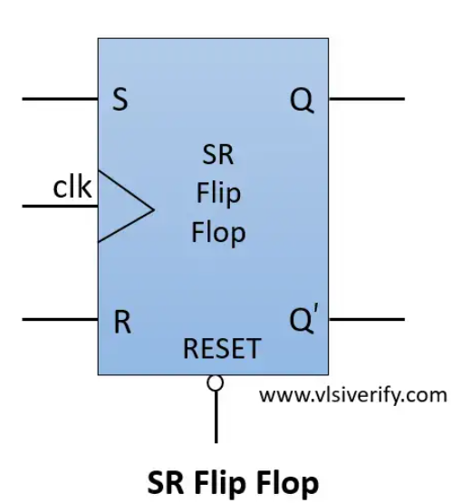

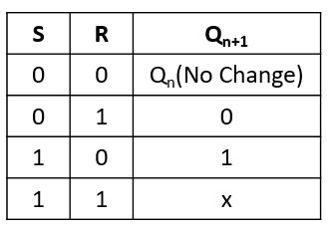

|  |
| --- |
| **Top module** |
| module lab3_ex3(SW,LEDR,LEDG);  input [17:0] SW;  output [17:0] LEDR;  output [7:0] LEDG;    assign LEDR=SW;    SR_flipflop(.s(SW[1]),.r(SW[0]),.clk(SW[2]),.rst(SW[3]),.q(LEDG[7]),.q_bar(LEDG[6]));  endmodule |
| **Code** |
| module SR_flipflop (s,r,clk,rst,q,q_bar);  input clk, rst, s, r;  output reg q;  output q_bar;    // always@(posedge clk or posedge rst) // for asynchronous reset  always@(posedge clk) begin // for synchronous reset  if(rst) q <= 0;  else begin  case({s,r})  2'b00: q <= q; // No change  2'b01: q <= 1'b0; // reset  2'b10: q <= 1'b1; // set  2'b11: q <= 1'bx; // Invalid inputs  endcase  end  end  assign q_bar = ~q;  endmodule |
| **Testbench** |
| module tb_SR_flipflop;  reg clk, rst, s, r;  wire q, q_bar;    SR_flipflop dff(s, r, clk, rst, q, q_bar);    always #2 clk = ~clk;  initial begin  clk = 0; rst = 1;  $display("Reset=%b --> q=%b, q_bar=%b", rst, q, q_bar);  #3 rst = 0;  $display("Reset=%b --> q=%b, q_bar=%b", rst, q, q_bar);    drive(2'b00);  drive(2'b01);  drive(2'b10);  drive(2'b11);  #5;  $finish;  end    task drive(input [1:0] ip);  begin  @(posedge clk);  {s, r} = ip;  #1 $display("s=%b, r=%b --> q=%b, q_bar=%b", s, r, q, q_bar);  end  endtask  endmodule |
|  |
|  |

1. JK Flip Flop

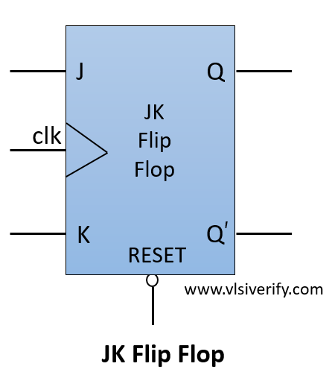

|  |
| --- |
| **Top module** |
| module lab3_ex4(SW,LEDR,LEDG);  input [17:0] SW;  output [17:0] LEDR;  output [7:0] LEDG;    assign LEDR=SW;    JK_flipflop(.j(SW[1]),.k(SW[0]),.clk(SW[2]),.rst(SW[3]),.q(LEDG[7]),.q_bar(LEDG[6]));  endmodule |
| **Code** |
| module JK_flipflop (j, k,clk,rst,q,q_bar);    input clk, rst, j, k;  output reg q;  output q_bar;    // always@(posedge clk or posedge rst) // for asynchronous reset  always@(posedge clk) begin // for synchronous reset  if(rst) q <= 0;  else begin  case({j,k})  2'b00: q <= q; // No change  2'b01: q <= 1'b0; // reset  2'b10: q <= 1'b1; // set  2'b11: q <= ~q; // Toggle  endcase  end  end  assign q_bar = ~q;  endmodule |
| **Testbench** |
| module tb_JK_flipflop;  reg clk, rst, j, k;  wire q, q_bar;    JK_flipflop dff(j, k, clk, rst, q, q_bar);    always #2 clk = ~clk;  initial begin  clk = 0; rst = 1;  $display("Reset=%b --> q=%b, q_bar=%b", rst, q, q_bar);  #3 rst = 0;  $display("Reset=%b --> q=%b, q_bar=%b", rst, q, q_bar);    drive(2'b00);  drive(2'b01);  drive(2'b10);  drive(2'b11); // Toggles previous output  drive(2'b11); // Toggles previous output  #5;  $finish;  end    task drive(input [1:0] ip);  begin  @(posedge clk);  {j,k} = ip;  #1 $display("j=%b, k=%b --> q=%b, q_bar=%b",j, k, q, q_bar);  end  endtask    endmodule |
|  |
|  |

1. T Flip Flop

|  |
| --- |
| **Top module** |
| module lab3_ex5(SW,LEDR,LEDG);  input [17:0] SW;  output [17:0] LEDR;  output [7:0] LEDG;    assign LEDR=SW;    T_flipflop (.clk(SW[2]),.rst(SW[1]),.t(SW[0]),.q(LEDG[7]),.q_bar(LEDG[6]));    endmodule |
| **Code** |
| module T_flipflop (clk, rst, t, q, q_bar);    input clk, rst, t;  output reg q;  output q_bar;    // always@(posedge clk or posedge rst) // for asynchronous reset  always@(posedge clk) begin // for synchronous reset  if(rst) q <= 0;  else begin  q <= (t?~q:q);  end  end  assign q_bar = ~q;  endmodule |
| **Testbench** |
| module tb_T_flipflop;  reg clk, rst, t;  wire q, q_bar;    T_flipflop dff(clk, rst, t, q, q_bar);    always #2 clk = ~clk;  initial begin  clk = 0; rst = 1;  $display("Reset=%b --> q=%b, q_bar=%b", rst, q, q_bar);  #3 rst = 0;  $display("Reset=%b --> q=%b, q_bar=%b", rst, q, q_bar);    drive(0); // Same as previous output  drive(1); // Toggles previous output  drive(1); // Toggles previous output  drive(1); // Toggles previous output  drive(0); // Same as previous output  #5;  $finish;  end    task drive(input ip);  begin  @(posedge clk);  t = ip;  #1 $display("t=%b --> q=%b, q_bar=%b",t, q, q_bar);  end  endtask    endmodule |
|  |
|  |

1. Right Shift Register 4-bit

|  |
| --- |
| **Top module** |
| module lab3_ex6(SW,LEDR,LEDG);  input [17:0] SW;  output [17:0] LEDR;  output [7:0]LEDG;  assign LEDR=SW;  shift_right_register DUT(.clk(SW[2]), .rst(SW[1]),.d_in(SW[0]),.d_out(LEDG[3:0]));  endmodule |
| **Code** |
| module shift_right_register(  input clk, // clock input  input rst, // reset input  input d_in, // data input  output reg [3:0] d_out // data output  );  always @(posedge clk or posedge rst) begin  if (rst) begin  d_out <= 4'b0000;  end  else  d_out<={d_in, d_out[3:1]};  end  endmodule |
| **Testbench** |
| module tb_shift_right_register;  reg clk, rst, d_in;  wire [3:0] d_out;  shift_right_register uut (  .clk(clk),  .rst(rst),  .d_in(d_in),  .d_out(d_out)  );  always #1 clk = ~clk;  initial begin  clk = 0;  rst = 1;  $display("Reset=%b --> d_out=%b", rst, d_out);  #10 rst = 0;  $display("Reset=%b --> d_out=%b", rst, d_out);  drive(1);  drive(0);  drive(1);  drive(1);  drive(0);  #5;  $finish;  end  task drive(input value);  begin  d_in = value;  #2;  $display("d_in=%b --> d_out=%b", d_in, d_out);  end  endtask  endmodule |
|  |
|  |

1. Left Shift Register 4-bit

|  |
| --- |
| **Top module** |
| module lab3_ex7(SW,LEDR,LEDG);  input [17:0] SW;  output [17:0] LEDR;  output [7:0]LEDG;  assign LEDR=SW;  shift_left_register DUT(.clk(SW[2]), .rst(SW[1]),.d_in(SW[0]),.d_out(LEDG[3:0]));  endmodule |
| **Code** |
| module shift_left_register(  input clk, // clock input  input rst, // reset input  input d_in, // data input  output reg [3:0] d_out // data output  );  always @(posedge clk or posedge rst) begin  if (rst) begin  d_out <= 4'b0000;  end  else  d_out<={d_out[2:0],d_in};  end  endmodule |
| **Testbench** |
| module tb_shift_left_register;  reg clk, rst, d_in;  wire [3:0] d_out;  shift_left_register uut (  .clk(clk),  .rst(rst),  .d_in(d_in),  .d_out(d_out)  );  always #1 clk = ~clk;  initial begin  clk = 0;  rst = 1;  $display("Reset=%b --> d_out=%b", rst, d_out);  #10 rst = 0;  $display("Reset=%b --> d_out=%b", rst, d_out);  drive(1);  drive(0);  drive(1);  drive(1);  drive(0);  #5;  $finish;  end  task drive(input value);  begin  d_in = value;  #2;  $display("d_in=%b --> d_out=%b", d_in, d_out);  end  endtask  endmodule |
|  |
|  |

1. Universal Register 4 bit

|  |
| --- |
| **Top module** |
| module lab3_ex8(SW,LEDR,LEDG);  input [17:0] SW;  output [17:0] LEDR;  output [7:0]LEDG;  assign LEDR=SW;  Universal_shift_register DUT(.clk(SW[3]), .rst(SW[2]),.shift_control(SW[1]),.d_in(SW[0]),.d_out(LEDG[3:0]));  endmodule |
| **Code** |
| module Universal_shift_register(  input clk, // clock input  input rst, // reset input  input shift_control,  input d_in, // data input  output reg [3:0] d_out // data output  );  always @(posedge clk or posedge rst) begin  if (rst) begin  d_out <= 4'b0000;  end  else  begin  if(shift_control) begin  d_out<={d_out[2:0],d_in}; // shift left  end  else begin  d_out<={d_in,d_out[3:1]}; // shift right  end  end  end  endmodule |
| **Testbench** |
| module tb_Universal_shift_register;  reg clk, rst, shift_control, d_in;  wire [3:0] d_out;  Universal_shift_register DUT (  .clk(clk),  .rst(rst),  .shift_control(shift_control),  .d_in(d_in),  .d_out(d_out)  );  always #1 clk = ~clk; // Clock with a period of 10 time units  initial begin  clk = 0; rst = 1; shift_control = 0; d_in = 0;  $display("Reset=%b, d_out=%b", rst, d_out);  #10 rst = 0;  $display("Reset=%b, d_out=%b", rst, d_out);  // Test shifting operations  drive(1, 1); // Shift left with d_in = 1  drive(1, 1); // Shift left with d_in = 1  drive(0, 0); // Shift right with d_in = 0  drive(0, 1); // Shift right with d_in = 1  drive(1, 1); // Shift left with d_in = 0  #10;  $finish;  end  task drive(input shift_ctl, input din);  begin  shift_control = shift_ctl;  d_in = din;  #2; // Wait for one clock cycle  $display("shift_control=%b, d_in=%b, d_out=%b", shift_control, d_in, d_out);  end  endtask  endmodule |
|  |
|  |

1. Universal Shift Register N-bit

|  |
| --- |
| **Top module** |
| module lab3_ex9(SW,LEDR,LEDG);  input [17:0] SW;  output [17:0] LEDR;  output [7:0]LEDG;  assign LEDR=SW;  Universal_shift_register_N_bit(.clk(SW[2]), .rst(SW[1]),.d_in(SW[0]),.d_out(LEDG[N-1:0]));  defparam DUT.N=4;  endmodule |
| **Code** |
| module Universal_shift_register #(parameter N = 4) (  input clk, // clock input  input rst, // reset input  input shift_control, // control for shift direction  input d_in, // data input  output reg [N-1:0] d_out // data output  );  always @(posedge clk or posedge rst) begin  if (rst) begin  d_out <= {N{1'b0}}; // Reset the output to 0's  end  else begin  if (shift_control) begin  d_out <= {d_out[N-2:0], d_in}; // Shift left (MSB gets d_in)  end  else begin  d_out <= {d_in, d_out[N-1:1]}; // Shift right (LSB gets d_in)  end  end  end  endmodule |
| **Testbench** |
| module tb_Universal_shift_register_N_bit;  reg clk, rst, shift_control, d_in;  wire [N-1:0] d_out;  parameter N = 4; // Can change to any desired size  Universal_shift_register #(.N(N)) DUT (  .clk(clk),  .rst(rst),  .shift_control(shift_control),  .d_in(d_in),  .d_out(d_out)  );  always #1 clk = ~clk; // Clock with a period of 2 time units  initial begin  clk = 0; rst = 1; shift_control = 0; d_in = 0;  $display("Reset=%b, d_out=%b", rst, d_out);  #10 rst = 0;  $display("Reset=%b, d_out=%b", rst, d_out);  // Test shifting operations  drive(1, 1); // Shift left with d_in = 1  drive(1, 1); // Shift left with d_in = 1  drive(0, 0); // Shift right with d_in = 0  drive(0, 1); // Shift right with d_in = 1  drive(1, 1); // Shift left with d_in = 1  #10;  $finish;  end  task drive(input shift_ctl, input din);  begin  shift_control = shift_ctl;  d_in = din;  #2; // Wait for one clock cycle  $display("shift_control=%b, d_in=%b, d_out=%b", shift_control, d_in, d_out);  end  endtask  endmodule |
|  |
|  |

1. Asynchronous Counter N-bit

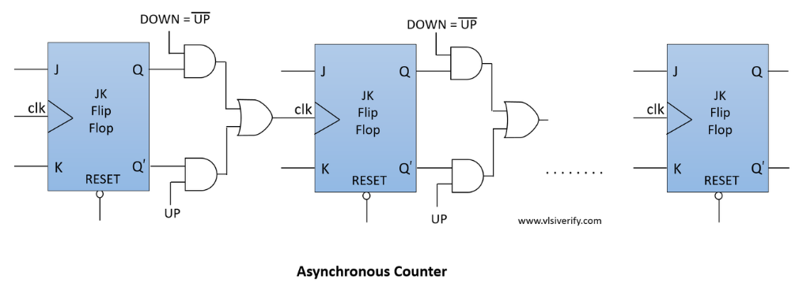

|  |
| --- |
| **Top module** |
| module lab3_ex10(SW,LEDR,LEDG);  input [17:0] SW;  output [17:0] LEDR;  output [7:0] LEDG;  assign LEDR=SW;  parameter N = 4;  asynchronous_counter DUT(.clk(SW[2]),.rst(SW[1]),.up_down(SW[0]),.cnt(LEDG[N-1:0]));  defparam DUT.N=N;  endmodule |
| **Code** |
| module asynchronous_counter #(parameter N = 4) (  input clk,  input rst,  input up_down,  output reg [N-1:0] cnt  );  always @(posedge clk or posedge rst) begin  if (rst) begin  cnt <= {N{1'b0}};  end  else begin  if (up_down && cnt < {N{1'b1}}) begin  cnt <= cnt + 1'b1;  end  else if (!up_down && cnt > 0) begin  cnt <= cnt - 1'b1;  end  end  end  endmodule |
| **Testbench** |
| module tb_asynchronous_counter;  parameter N = 4; // Declare 'N' parameter her  reg clk, rst, up_down;  wire [N-1:0] cnt; // Wire 'cnt' width is now based on 'N'  asynchronous_counter #(.N(N)) DUT (  .clk(clk),  .rst(rst),  .up_down(up_down),  .cnt(cnt)  );  always #5 clk = ~clk; // Clock with a period of 10 time units  initial begin  // Initial values  clk = 0; rst = 1; up_down = 1;  $display("rst=%b, up_down=%b, cnt=%b", rst, up_down, cnt);    // Apply reset  #10 rst = 0;  $display("rst=%b, up_down=%b, cnt=%b", rst, up_down, cnt);  // Test counting up  drive(1); // cnt = 1  drive( 1); // cnt = 2  drive( 1); // cnt = 3  drive(1); // cnt = 4  // Test counting down  up_down = 0;  drive( 0); // cnt = 3  drive( 0); // cnt = 2  drive( 0); // cnt = 1  drive( 0); // cnt = 0  // Test reset  rst = 1;  #10 rst = 0;  $display("rst=%b, up_down=%b, cnt=%b", rst, up_down, cnt);  #10;  $finish;  end  // Task to drive up_down and observe the counter  task drive(input up_dn);  begin  up_down = up_dn;  #10;  $display("rst=%b, up_down=%b, cnt=%b", rst, up_down, cnt);  end  endtask  endmodule |
|  |
|  |

1. Synchronous Counter n-bit

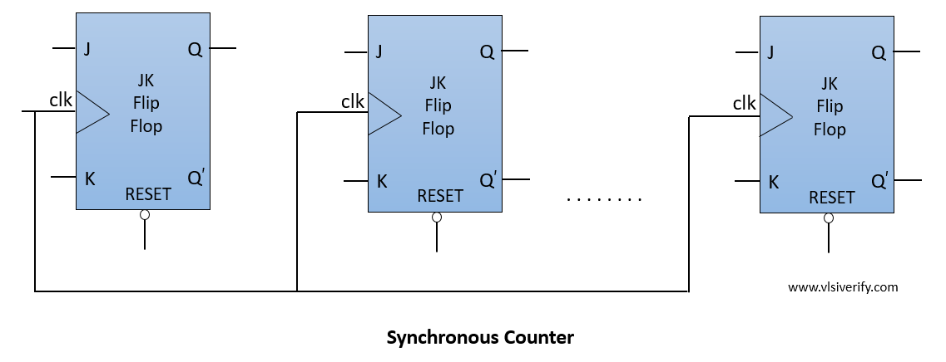

|  |
| --- |
| **Top module** |
| module lab3_ex11(SW,LEDR,LEDG);  input [17:0] SW;  output [17:0] LEDR;  output [7:0] LEDG;  assign LEDR=SW;  parameter N = 4;  synchronous_counter DUT(.clk(SW[2]),.rst(SW[1]),.up_down(SW[0]),.cnt(LEDG[N-1:0]));  defparam DUT.N=N;  endmodule |
| **Code** |
| module synchronous_counter(clk, rst, up_down, cnt);  parameter N = 4;  input clk, rst;  input up_down;  output reg [N-1:0] cnt;  always @(posedge clk) begin  if (rst) begin  cnt <= {N{1'b0}};  end  else begin  if (up_down && cnt < {N{1'b1}}) begin  cnt <= cnt + 1'b1;  end  else if (!up_down && cnt > 0) begin  cnt <= cnt - 1'b1;  end  end  end |
| **Testbench** |
| module tb_synchronous_counter;  parameter N = 4;    reg clk, rst, up_down;  wire [N-1:0] cnt;    synchronous_counter DUT (  .clk(clk),  .rst(rst),  .up_down(up_down),  .cnt(cnt)  );  always #5 clk = ~clk;  initial begin  clk = 0; rst = 1; up_down = 1;  $display("rst=%b, up_down=%b, cnt=%b", rst, up_down, cnt);    #10 rst = 0;  $display("rst=%b, up_down=%b, cnt=%b", rst, up_down, cnt);    // Test counting up  drive(1); // cnt = 1  drive(1); // cnt = 2  drive(1); // cnt = 3  drive(1); // cnt = 4    // Test counting down  up_down = 0;  drive(0); // cnt = 3  drive(0); // cnt = 2  drive(0); // cnt = 1  drive(0); // cnt = 0    // Test reset  rst = 1;  #10 rst = 0;  $display("rst=%b, up_down=%b, cnt=%b", rst, up_down, cnt);    #10;  $finish;  end  task drive(input up_dn);  begin  up_down = up_dn;  #10;  $display("rst=%b, up_down=%b, cnt=%b", rst, up_down, cnt);  end  endtask  endmodule |
|  |
|  |

For each circuit, Do the following steps:

Step 1 : Draw the Schematic of this circuit

### (Show Schematic in Lab report)

Step 2 : Write the truth Table for this circuit

### (Show The Truth Table in Lab report)

Step 3 : Write the Verilog Module to implement this circuit ( using structural, data flow, and behavior modeling)

### (Show Verilog codes of this module in Lab report)

Step 4 : Write the testbench to simulate the Verilog modules of this circuit

### (Show simulation results in Lab report)

Step 5 : Write the Top-level Verilog Code to implement the Verilog modules of this circuit in DE2-FPGA Kit

### (Show implementation results in Lab report)

**IV. LAB REPORT GUIDELINES**

Students write up a report on the Verilog HDL implementation experiment projects created in this lab. The lab report should include Circuit Schematics, Verilog Module Codes, Verilog test bench codes, Top level module to implement the required circuit in FPGA KIT and evidences of data output evidences to validate the experiments (The Captured Screens, Photo of FPGA Kit implementation results).